Book: Time Series Analysis and its Application

**ARMA Models**

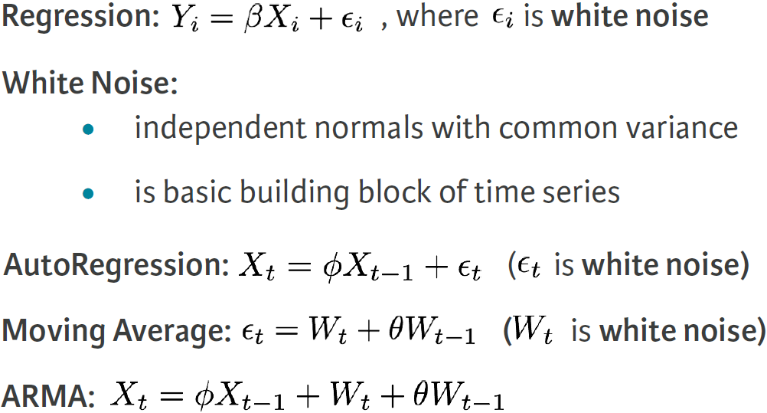

**Stationary Time Series**

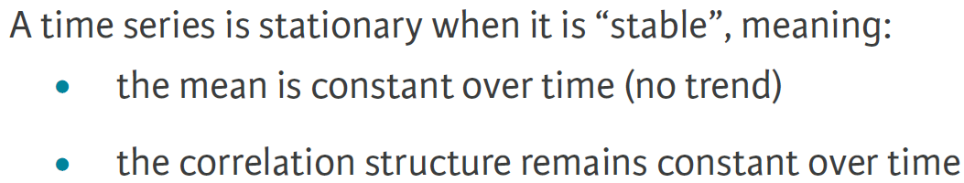

**Dealing with Trend and Heteroscedasticity**

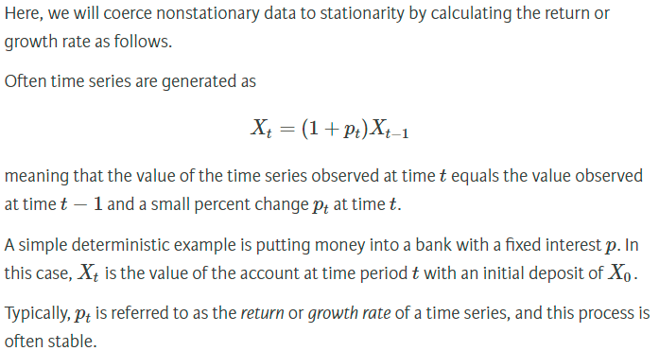

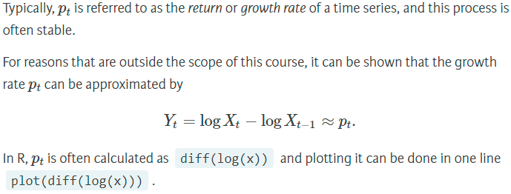

**Stationary Time Series: ARMA**

**Wold Decomposition**

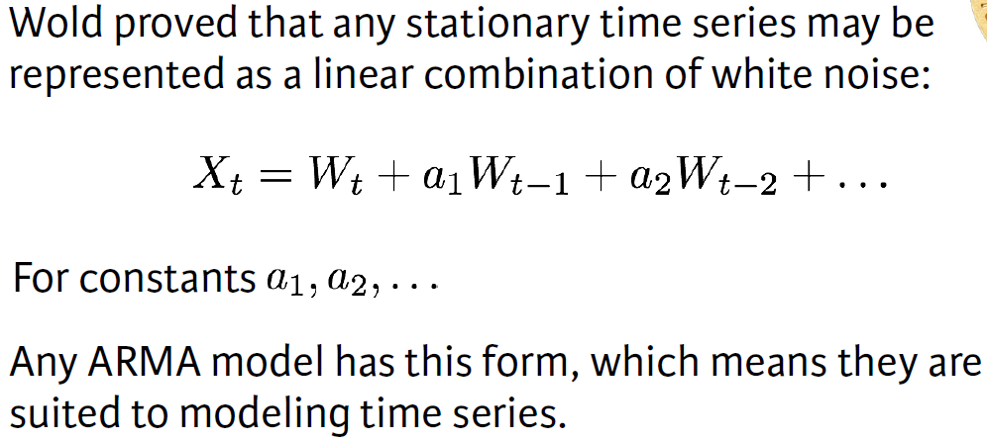

**ARMA simulation**

MA(1) : Xt = Wt + 0.9 Wt-1  => arima.sim( list(order=c(0,0,1), ma=0.9), n=100 )

AR(2) : Xt = **0**Xt-1 - 0.9 Xt-2 + Wt => arima.sim( list(order=c(2,0,0), ar=c(**0**,-0.9)), n=100 )

**ACF and PACF**

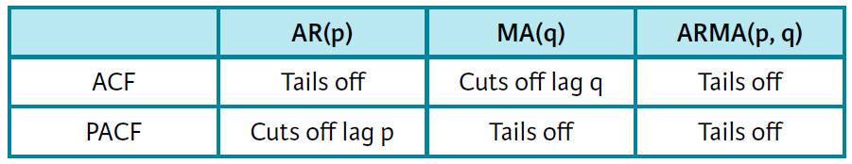

|  |  |
| --- | --- |
|  |  |

Estimation with **astsa:** sarima(x, p, d, q)

**Model Choice and Residual Analysis**

**AIC and BIC**

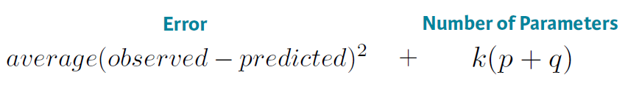

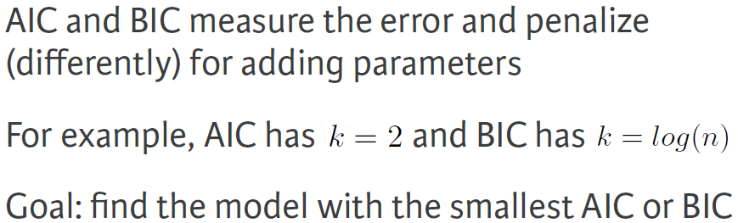

If AIC selects one models and BIC selects the other one, go for the simpler model, the one with the minimum value of p, d, q

**Residual Analysis**

Make sure residual are white Gaussian noise

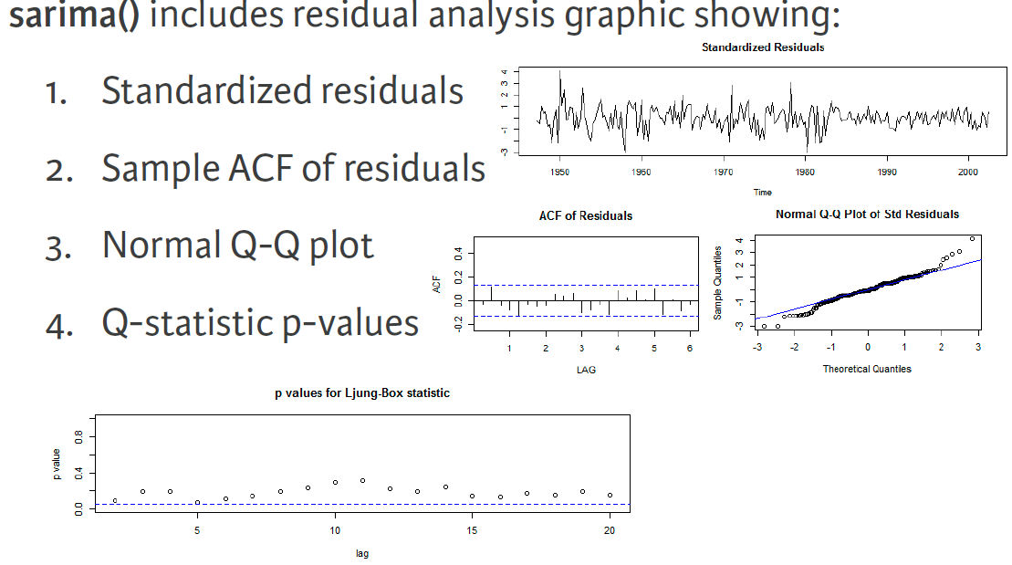

**ARIMA**

Identifying ARIMA: a time series exhibits ARIMA behavior if the ***differenced data*** has ARMA behavior.

|  |  |
| --- | --- |
|  |  |

**Forecasting ARIMA**

sarima.for(x, n.ahead, p, d, q)

**Pure Seasonal Models**

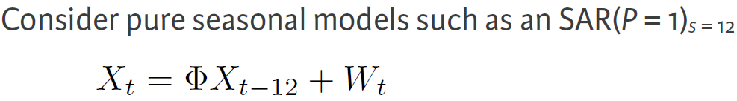

**ACF and PACF**

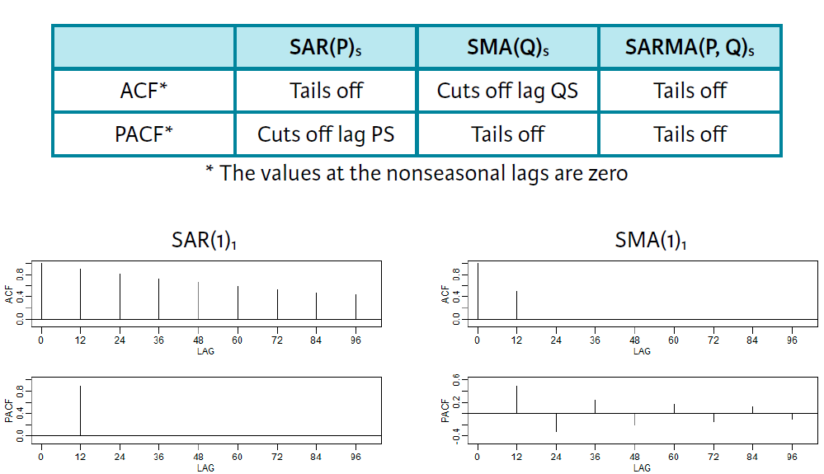

**SAR(P)S**, **SMA(Q)S**, or **SARMA(P,Q)S** for the pure seasonal AR, MA or ARMA with seasonal period S

**Fitting a pure seasonal model**

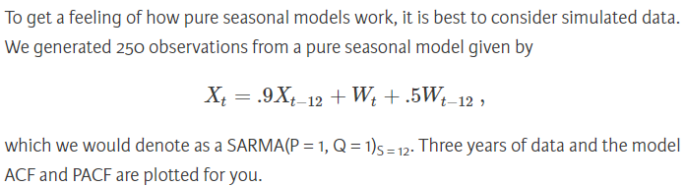

sarima(x, p = 0, d = 0, q = 0, P = 1, D = 0, Q = 1, S = 12)

**Mixed Seasonal Models**

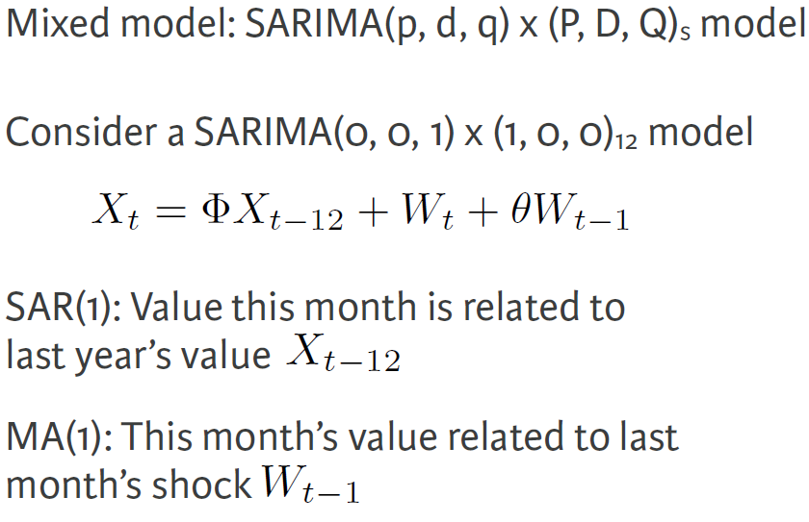

|  |  |
| --- | --- |
|  | **Seasonal**: ACF tails off and PACF cuts off, suggesting a SAR model.  **Non-seasonal**: ACF cuts off and PACF tails off, suggesting a MA model. |

**Example: Air Passenger**

|  |  |
| --- | --- |
| **dlx** has seasonal component  **ddlx** is stationary |  |
| ar1 isn’t significant, so remove it. | Also perform **residual analysis** to check if they are white noise. |